Navigation:
Self Service > Student Center

Page | Action(s) to be taken
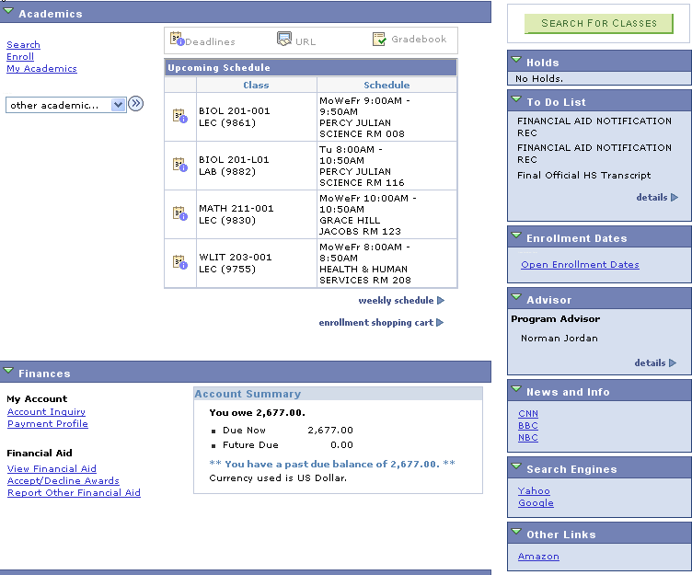  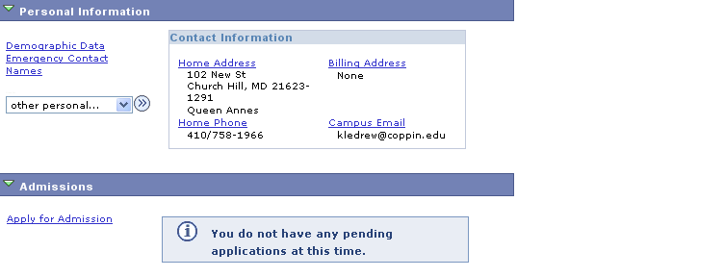 | - Click My Academics link.
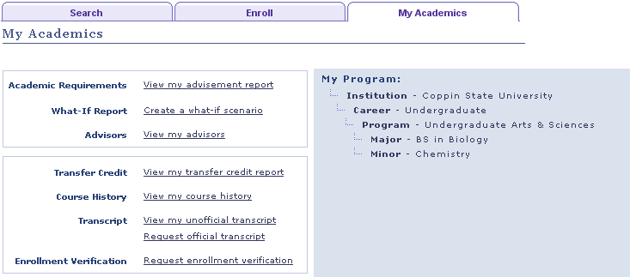 | - Click .
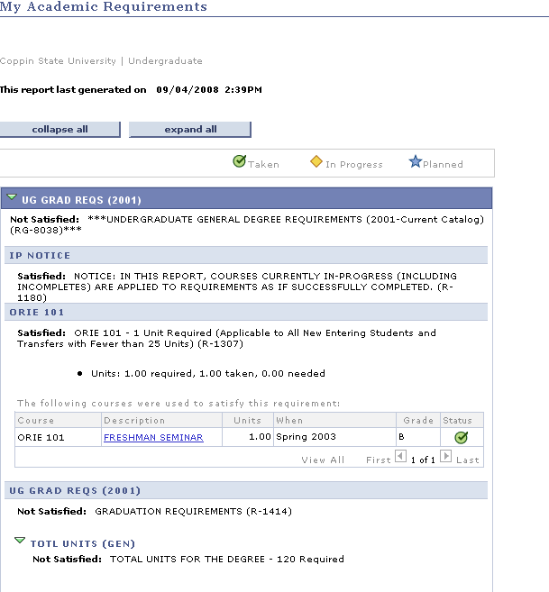 | - You can review your advisement report on the My Academic Requirements page. Where degree requirements have been satisfied, the section is collapsed; where not yet satisfied, the section is expanded.  Icons on the page explain the significance of courses displayed for the degree requirements.  - Follow the links or tabs to continue using Self Service.

