Navigation:
Self Service > Student Center

Page | Action(s) to be taken
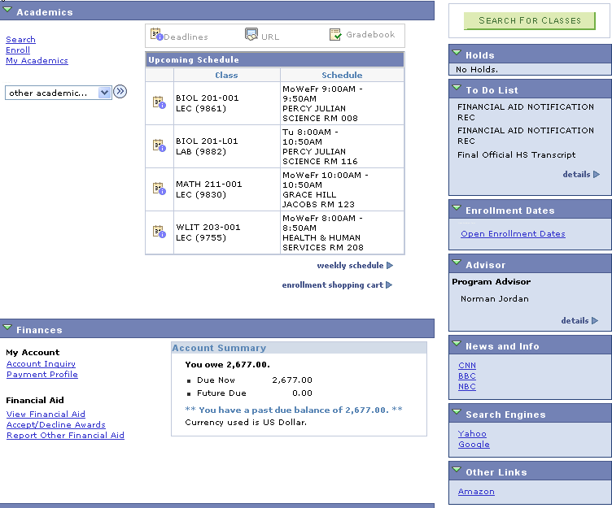  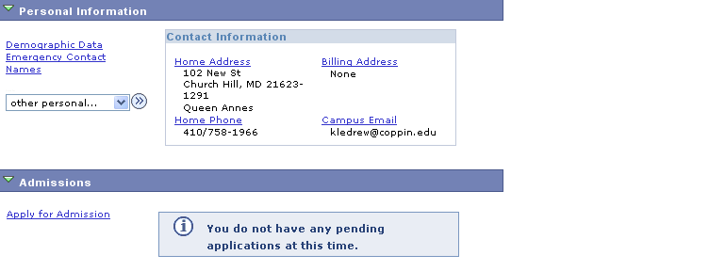 | - View Advisor section on the Student Center page.  - Click for more information about your advisors.
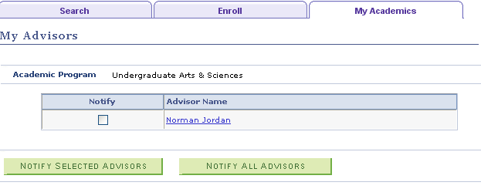 | - You can send an email to your Advisor by clicking on the link related to his/her name.  - Alternatively, you can send a notification to all or selected advisors (where you have multiple advisors) by clicking or
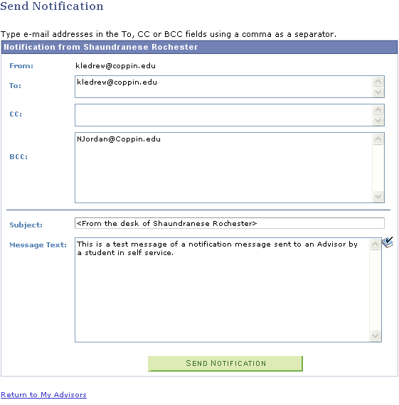 | - On the Send Notification page, you can compose a detailed message to send to one or more Advisors whose email addresses appear in the BCC area.  The sender’s information appears in the Subject line.  - Click to use spell check on your message.  - Click to send the message.
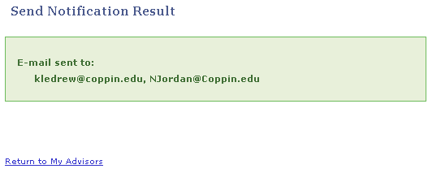 | - You will receive a message indicating the send notification result.  - Follow the links or tabs to continue using Self Service.

