Navigation:
Self Service > Student Center or
Self Service > Class Search

Page | Action(s) to be taken
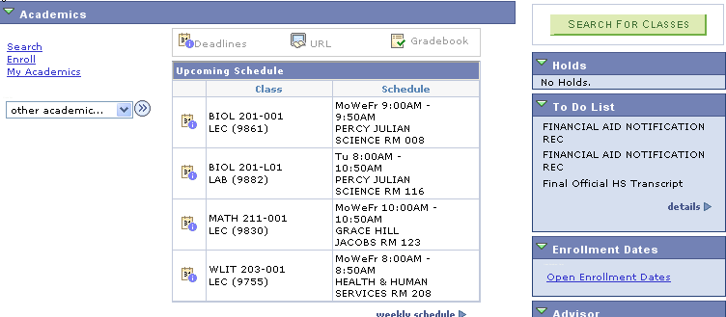 | - Click Search link if you search for classes via the Student Center.
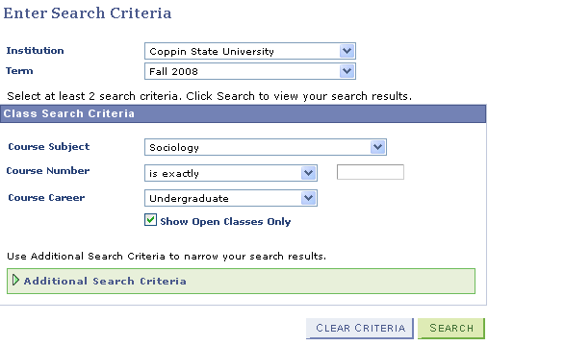 | - Enter Search Criteria page includes:  - Institution - Coppin State University defaults  - Term – Current Term defaults. You can alter the term by choosing from the available terms in the drop down list.  - Select a subject from the drop down list.  - Click
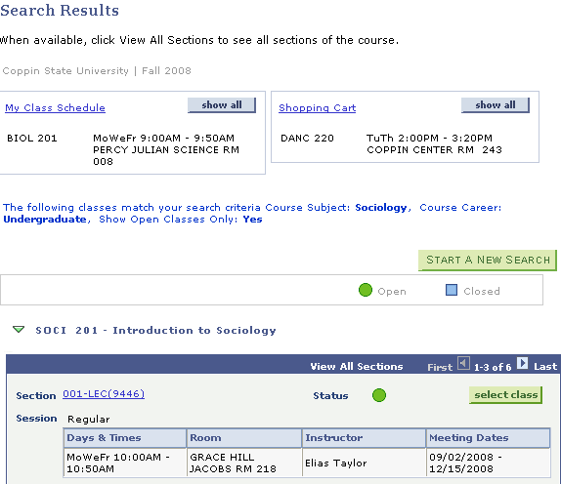 | - Only courses that satisfy the search criteria display in the Search Results page.  - If Class Schedule exists click  - If Shopping Cart exists click
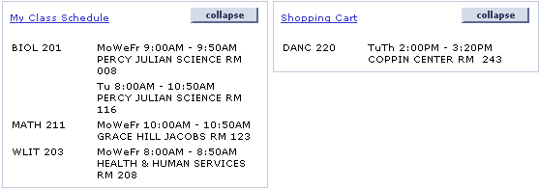  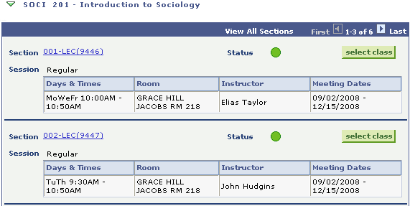 | - Compare classes in schedule & shopping cart to available sections from class search and select a section that has no time conflicts.  - Click
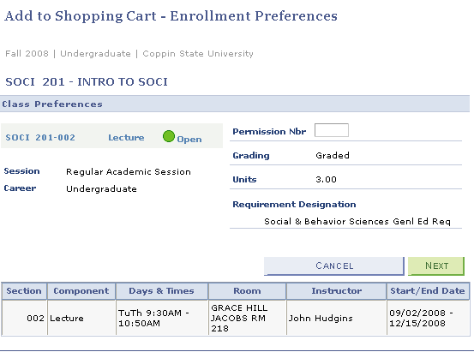 | - Add to Shopping Cart page displays your selection.  - Click to complete addition to shopping cart.
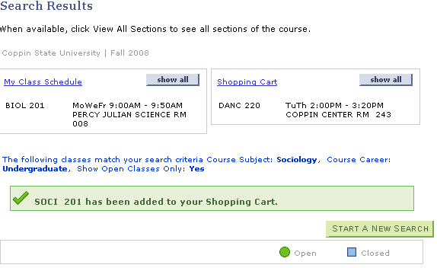 | - Message displays confirming class has been added to Shopping Cart.  - Click to continue adding classes to the Shopping Cart.

