Navigation:
Self Service > Faculty Center

Page | Action(s) to be taken
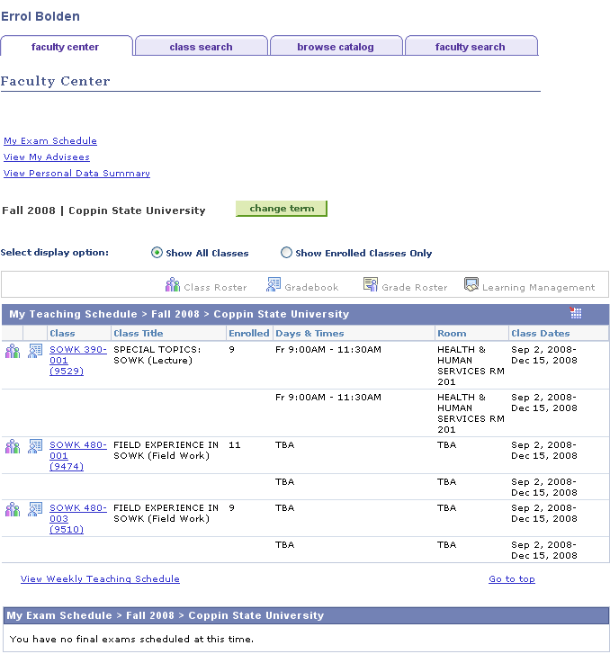 | - Click
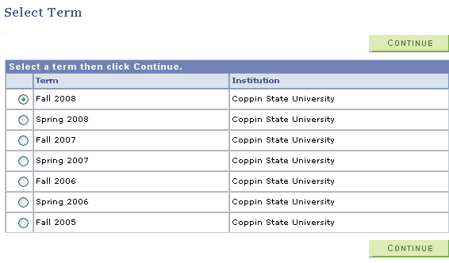 | - Select the Term for which you wish to view your teaching schedule by pressing on the radio button beside the term in the listing.  - Click
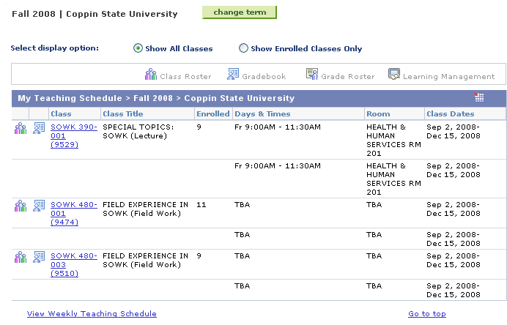 | - Click a class link to view course details.
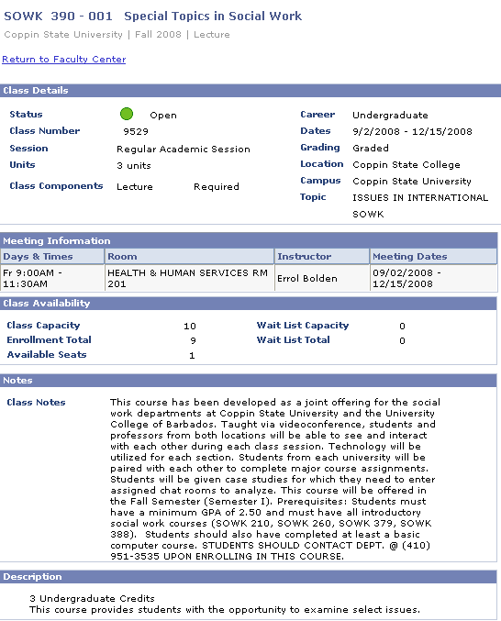 | - Press the 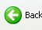button on the browser to return to the list of classes you are teaching for a specified term.
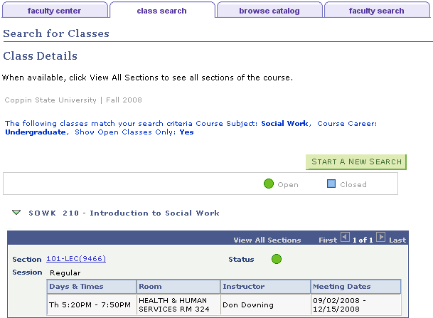 | - Press if you want to continue searching for classes.  - Press on the faculty center tab or Return to Faculty Center to continue with other functions.

