Navigation:
Campus Solution > Self Service> Faculty Center>

Page | Action(s) to be taken
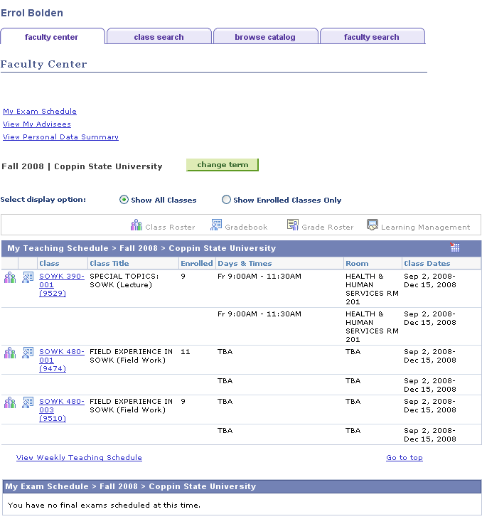 | - Click
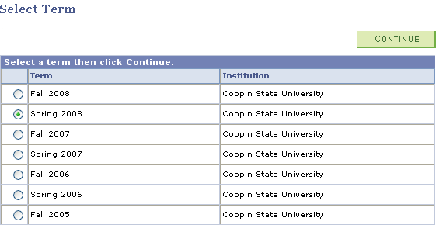 | - Select the Term for which you wish to enter your mid-term grades by pressing on the radio button beside the term in the listing.  - Click
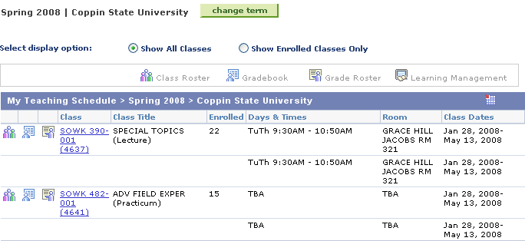 | - On the teaching schedule, click beside the class section to select the roster for which you wish to enter grades.
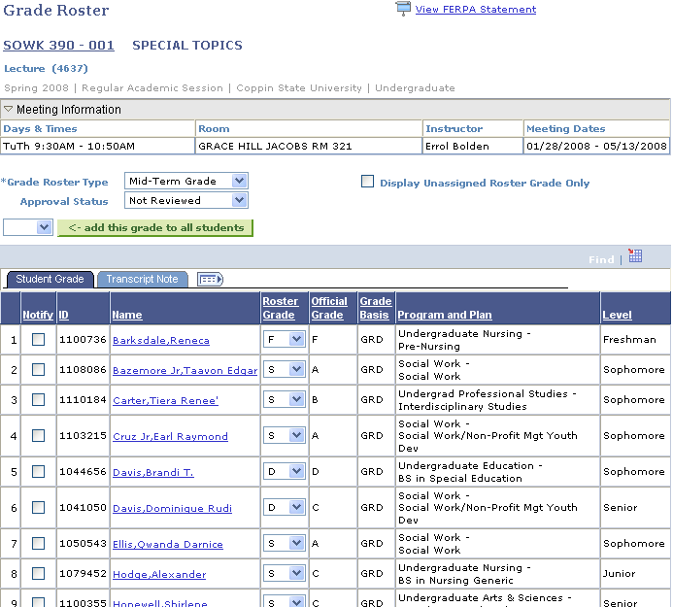  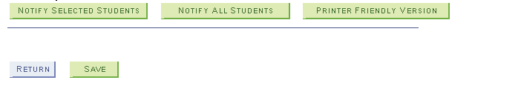 | - Select Grade Roster Type = Mid-Term Grade & Approval Status = Not Reviewed  - Select the mid-term grade from the Roster Grade drop down list in the Roster Grade column.  - If only a subset of mid-term grades have been entered click and go to step 10.  - If all mid-term grades have been entered, select Approval Status = Ready for Review.  - Click  - Click

