Navigation:
Campus Solution > Self Service> Faculty Center>

Page | Action(s) to be taken
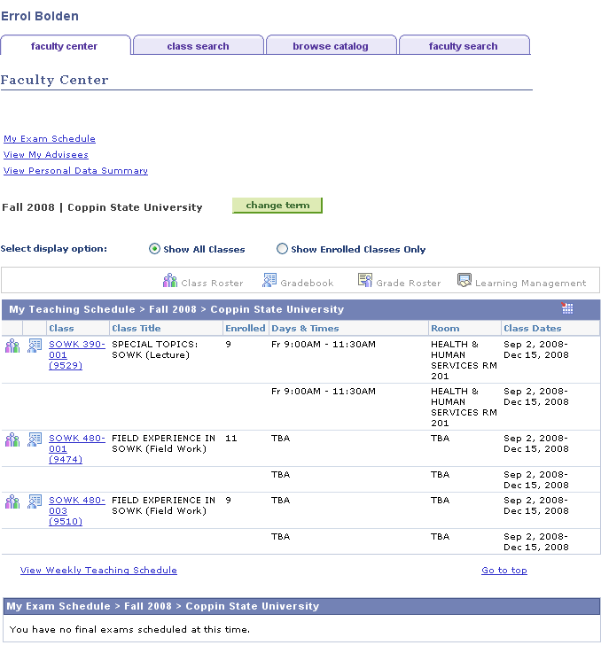 | - Click
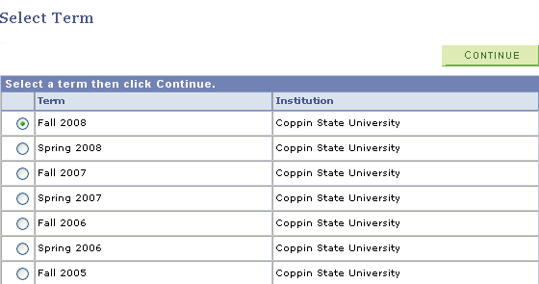 | - Select the Term for which you wish to enter your final grades by pressing on the radio button beside the term in the listing.  - Click
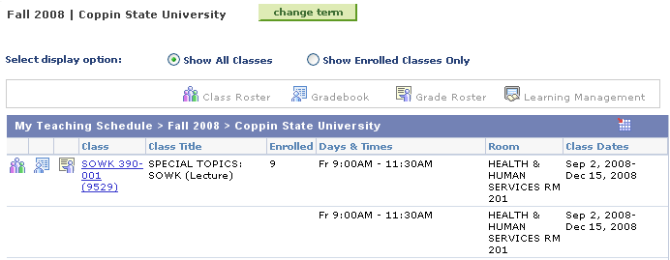 | - On the teaching schedule, click beside the class section to select the roster for which you wish to enter grades.
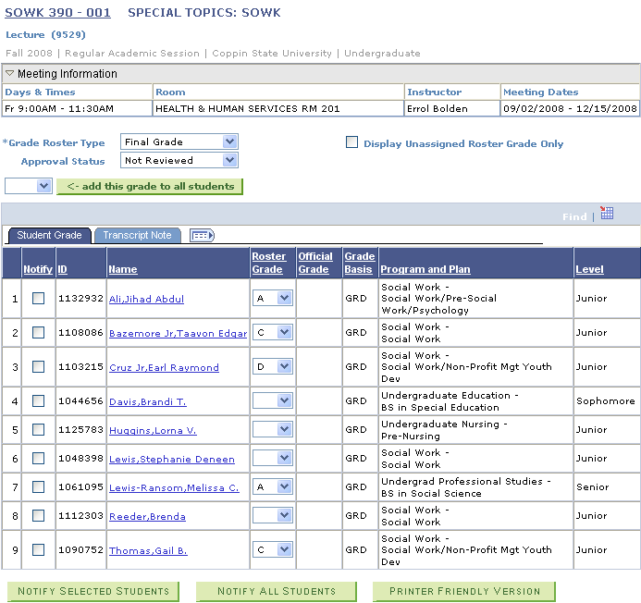 | - Select Grade Roster Type = Final Grade and Approval Status = Not Reviewed  - Select the Final grade from the Roster Grade drop down list in the Roster Grade column.  - If only a subset of final grades have been entered click and go to step 10.  - If all final grades have been entered, set Approval Status = Approval.  - Click  - Click

